# Water electrolysis, pure fully renewables

* How to allocate emissions to oxygen
* How to calculate the share of RFNBO with emissions from auxiliaries

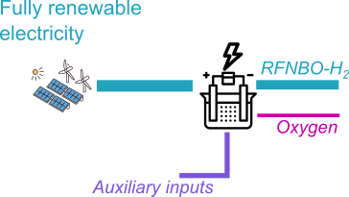

Fully renewable electricity is attributed zero GHG emissions. Therefore, the only emissions come from auxiliaries.

They are allocated to the co-products by the economic value (15(f), because oxygen has no energy content).

## Assumptions:

Fully renewable electricity carbon intensity: $ci_{ren}=0 \frac{g CO_{2}eq}{kWh}$

Efficiency of the electrolyser $η_{ely}=60\%$

Auxiliaries carbon intensity: $ci_{aux}=5 \frac{g CO_{2}eq}{{MJ}_{hydrogen}}$  
economic value of RFNBO hydrogen: $v_{hydrogen}=6 \frac{€}{{kg}_{hydrogen}}$  
economic value of oxygen: $v_{oxygen}=0.3 \frac{€}{{kg}_{oxygen}}$  
mass of produced oxygen per kg of hydrogen: $r_{oh}=8 \frac{{kg}_{oxygen}}{{kg}_{hydrogen}}$

## Calculation:

Emissions attributed to hydrogen: $E=ci_{ren}*η+ {ci}_{aux}*\frac{v_{hydrogen}}{v_{hydrogen}+v_{oxygen}*r_{oh} } =3.57\frac{g CO_{2}eq}{{MJ}_{hydrogen}}$

Share of RFNBO in the output is $s_{RFNBO_H2}= 100\%$

## Conclusion:

This case study shows that the share of RFNBO is calculated on the energy share of relevant inputs, while emissions are calculated based on all emissions, including auxiliaries. The emissions can be attributed to co-products, in case of products without energy content, economic allocation is used.

# Fully renewable and grid electricity

How to average over different timeframes

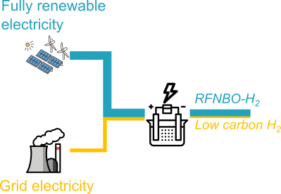

Electrolyser running at 764 MW with a mix of mostly renewable electricity, complemented by grid electricity.

## Assumptions:

|  |  |  |
| --- | --- | --- |
| Parameter | Monthly averaging | Hourly averaging |
| Grid carbon intensity $ci_{grid}$ | $$100 \frac{g CO_{2}eq}{kWh}$$ | |
| Relevant renewable electricity used $el_{ren}$ | $$500 GWh$$ | $$264 MWh$$ |
| Relevant grid electricity used $el_{grid_ely }$ | $$50 GWh$$ | $$500 MWh$$ |
| Grid electricity for auxiliaries $el_{grid_aux}$ | $$0.5 GWh$$ | $$0.7 MWh$$ |
| Efficiency of the electrolyser $η_{ely}$ | $$60\%$$ | |

## Calculation:

### Monthly averaging:

Share of RFNBO in the output is $s_{RFNBO_H2}= \frac{el_{ren}}{el_{ren}+{el}_{grid_ely} }=\frac{500 GWh}{550 GWh}≈91\%$

Total carbon intensity: ${ci}_{H2}= \frac{\left({el}_{grid_ely}+el_{grid_aux}\right) ci_{grid}}{\left(el_{ren}+{el}_{grid_ely}\right) η_{ely} }=\frac{50.5 GWh*100 g/kWh}{550 GWh*60\%}≈4.3\frac{g CO_{2}eq}{MJ}$

### Hourly averaging, low renewables:

Total carbon intensity: ${ci}_{H2}= \frac{\left({el}_{grid_{ely}}+el_{grid_{aux}}\right) ci_{grid}}{\left(el_{ren}+{el}_{grid_{ely}}\right) η_{ely} }=\frac{500.7 MWh*100\frac{g}{kWh}}{764 MWh*60\%}≈30.3\frac{g CO_{2}eq}{MJ}$

Share of RFNBO in the output is $s_{RFNBO_H2}=0\%$ because threshold of 28.2 g/MJ is not met.

## Conclusion:

This case study shows how averaging over shorter time scales can exclude some periods with low renewables from the RFNBO production. In other cases that are not shown here, the contrary could happen that the average over a longer period has a too high carbon intensity to qualify.

# Ammonia + cracking

How to determine if an energy input is “relevant”

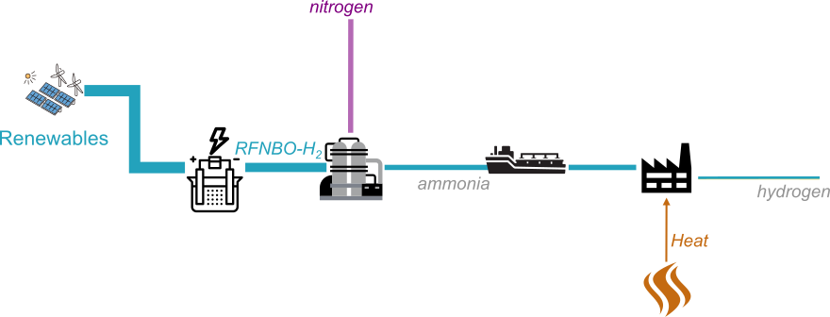

Cracking Ammonia is endothermic, the heat can be supplied electrically or by burning part of the ammonia. Here we assume that the energy is supplied electrically.

## Assumptions:

Hydrogen demand Haber process (ammonia production): ${hydrogen}_{input}=1.16 \frac{MJ_{H_{2}}}{MJ_{{NH}_{3}}}$

Electricity demand Haber process: $el_{grid_Haber }=0.75 \frac{MJ_{el}}{MJ_{NH_{3}}}$

Grid carbon intensity: $ci_{grid}=100 \frac{g CO_{2}eq}{kWh}$

Electricity demand cracking process $el_{grid_cracking }=0.3 \frac{MJ_{el}}{MJ_{H_{2}}}$

Ammonia demand for cracking: ${ammonia}_{input}=0.88 \frac{MJ_{NH_{3}}}{MJ_{H_{2}}}$

As the output energy is bigger than the input energy, the electricity used in the cracking process needs to be considered as a relevant input.

## Calculation:

Total carbon intensity: ${ci}_{H_{2}}=\left({ammonia}_{input}*el_{grid_{Haber}}+el_{grid_cracking }\right)* ci_{grid} ≈26.7\frac{g CO_{2}eq}{MJ}$

Share of RFNBO in the output is $s_{RFNBO_H2}= \frac{{ammonia}_{input} * {hydrogen}_{input}}{{{ammonia}_{input} * hydrogen}_{input} + el_{grid_cracking } }=\frac{1.02 MJ}{1.02+0.3 MJ}≈77\%$

## Conclusion:

This case study shows that some transport processes that need energy to split the transported product at destination might need to consider the energy needed for the split as relevant energy. If this energy is not fully renewable, the share of RFNBO will decrease.

# rWGS+FT to kerosene

How to count different integrated processes together

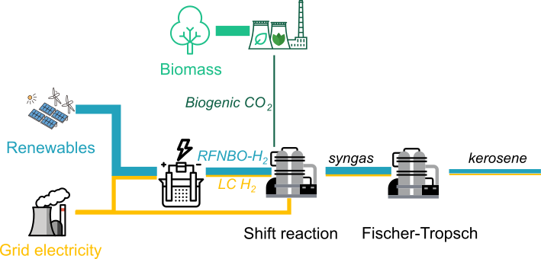

Hydrogen production as before, shift with CO2 and FT to kerosene, assuming only kerosene as output to simplify the example.

The shift reaction and Fischer Tropsch can be either seen as an integrated process, or as two separate processes. It is allowed to choose either one. We first calculate if the reaction adds to the heating value, in which case the grid electricity used for heating the reactor has to be counted as relevant input.

## Assumptions:

Relevant grid electricity used for the shift reaction: $el_{grid_shift }=80 GWh$

Shift reaction grid carbon intensity: $ci_{grid_shift}=18 \frac{g CO_{2}eq}{kWh}$

Amount of hydrogen produced: ${prod}_{H2}=\left(el_{ren}+{el}_{grid_{ely}}\right) η_{ely}=550 GWh*60\%≈330 GWh$

Hydrogen carbon intensity: ${ci}_{H2}=30.3\frac{g CO_{2}eq}{MJ}$

Efficiency of the shift reaction $η_{shift}=99\%$

Share of the (electric) heat energy ending up in the syngas: $s_{heat_to_heating_value}=10\%$

Efficiency of the FT reaction $η_{FT}=70\%$

## Calculation:

### If looking only at the shift reaction:

Energy coming out of the shift reaction: ${En}_{output}={prod}_{H2}*η_{shift}+el_{grid_shift}*s_{heat_to_heating_value}=334.7 GWh$

This is higher than the hydrogen input, so the electricity has to be considered a relevant input.

Total carbon intensity: ${ci}_{kerosene}= \frac{\left({el}_{grid_ely}+el_{grid_aux}\right) * ci_{grid}+el_{grid_shift }* ci_{grid_shift}}{{En}_{output} * η_{FT}}=\frac{50.5 GWh*100\frac{g}{kWh}+80 GWh*18 g/kWh}{334.7 GWh*70\%}≈27.7\frac{g CO_{2}eq}{MJ}$

Share of RFNBO in the output is $s_{RFNBO_kerosene}= \frac{el_{ren}}{el_{ren}+{el}_{grid_ely}+el_{grid_shift } }=\frac{500 GWh}{630 GWh}≈79\%$

### If looking at the shift and FT reaction as an integrated process:

Energy coming out of the FT reaction: ${En}_{output}=\left({prod}_{H2}*η_{shift}+el_{grid_shift}*s_{heat_to_heating_value}\right)*η_{FT} =234.3 GWh$

This is lower than the hydrogen input, so the electricity does not have to be considered a relevant input.

Total carbon intensity as before: ${ci}_{kerosene}≈27.7\frac{g CO_{2}eq}{MJ}$

Share of RFNBO in the output is $s_{RFNBO_H2}= \frac{el_{ren}}{el_{ren}+{el}_{grid_ely} }=\frac{500 GWh}{550 GWh}≈91\%$

## Conclusion:

This case study shows that if looking at the processes separately, under certain circumstances it is possible that the energy content is increased, and that the electricity has to be counted as relevant input. In this case, the share of RFNBO in the output changes, but the carbon intensity remains the same.

# Biogenic syngas with surplus CO and RFNBO hydrogen

How to split biogenic and RFNBO-parts

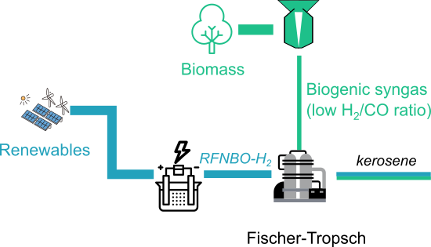

Instead of using a shift reaction to increase the H2/CO ratio in biogenic syngas, RFNBO hydrogen is added to the Fischer-Tropsch process. According to the “co-processing exception” in Annex A point 1, a distinction on a proportional basis of the energetic value of inputs shall be made.

## Assumptions:

Efficiency of the FT reaction $η_{FT}=70\%$

Fully renewable electricity carbon intensity: $ci_{ren}=0 \frac{g CO_{2}eq}{kWh}$

Biogenic syngas carbon intensity: $ci_{bio_syngas}=20 \frac{g CO_{2}eq}{{MJ}_{syngas}}$

Energy ratio of syngas to hydrogen: $r_{sh}=4 \frac{MJ_{syngas}}{MJ_{hydrogen}}$

## Calculation:

Total carbon intensity: ${ci}_{RFNBO-kerosene}=0 \frac{g CO_{2}eq}{MJ}$

$${ci}_{bio-kerosene}=\frac{ci_{bio_syngas}}{η_{FT}}= 28.6 \frac{g CO_{2}eq}{MJ}$$

Share of RFNBO in the output is $s_{RFNBO_kerosene}= \frac{1}{1+r_{sh}}=0.2$

## Conclusion:

This case study shows that the streams are separated based on the energy in the inputs, and then the carbon intensity is calculated for each stream separately.

# Partly replacing fossil inputs like in coal Fischer Tropsch

How to split RFNBO part from fossil inputs

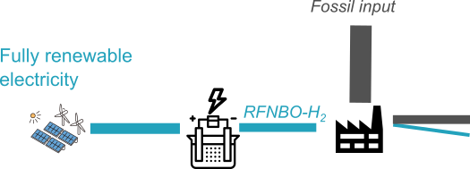

Very similar to the biogenic syngas case, the fossil process part can be virtually split from the RFNBO part.

## Assumptions:

Efficiency of the FT reaction $η_{FT}=70\%$

Fully renewable electricity carbon intensity: $ci_{ren}=0 \frac{g CO_{2}eq}{kWh}$

Fossil syngas carbon intensity: $ci_{syngas}=120 \frac{g CO_{2}eq}{{MJ}_{syngas}}$

Energy ratio of syngas to hydrogen: $r_{sh}=9 \frac{MJ_{syngas}}{MJ_{hydrogen}}$

## Calculation:

Total carbon intensity: ${ci}_{RFNBO-kerosene}=0 \frac{g CO_{2}eq}{MJ}$

$${ci}_{fossil-kerosene}=\frac{ci_{syngas}}{η_{FT}}= 171.4 \frac{g CO_{2}eq}{MJ}$$

Share of RFNBO in the output is $s_{RFNBO_kerosene}= \frac{1}{1+r_{sh}}=0.1$

## Conclusion:

Even if the fossil part doesn’t respect the 70% GHG reduction, the energetic share of RFNBO in the inputs can still be virtually split from the process and the corresponding output can be declared as RFNBO.

# Methanol+transport+MTJ

Transport, mixing RFNBOs

